Exp:6
#include <stdio.h>
#include <ctype.h>

int main() {
char a[10];
int flag = 1, i = 1;

printf("\nEnter an identifier: ");
fgets(a, sizeof(a), stdin);

if (isalpha(a[0])) {
while (a[i] != '\0') {
if (!isdigit(a[i]) && !isalpha(a[i])) {
flag = 0;
break;
}
i++;
}
} else {
flag = 0;
}

if (flag == 1) {
printf("\nValid identifier\n");
} else {
printf("\nNot a valid identifier\n");
}

return 0;
}

Output:
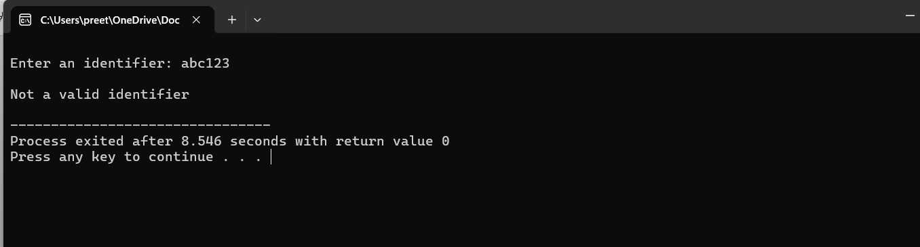

Exp:7
#include<stdio.h>
#include<ctype.h>
void FIRST(char[],char );
void addToResultSet(char[],char);
int numOfProductions;
char productionSet[10][10];
int main()
{
int i;
char choice;
char c;
char result[20];
printf("How many number of productions ? :");
scanf(" %d",&numOfProductions);
for(i=0;i<numOfProductions;i++)//read production string eg: E=E+T
{
printf("Enter productions Number %d : ",i+1);
scanf(" %s",productionSet[i]);
}
do
{
printf("\n Find the FIRST of :");
scanf(" %c",&c);
FIRST(result,c); //Compute FIRST; Get Answer in 'result' array
printf("\n FIRST(%c)= { ",c);
for(i=0;result[i]!='\0';i++)
printf(" %c ",result[i]); //Display result
printf("}\n");
printf("press 'y' to continue : ");
scanf(" %c",&choice);
}
while(choice=='y'||choice =='Y');
}
/*
*Function FIRST:
*Compute the elements in FIRST(c) and write them
*in Result Array.
*/
void FIRST(char* Result,char c)
{
int i,j,k;
char subResult[20];
int foundEpsilon;
subResult[0]='\0';
Result[0]='\0';
//If X is terminal, FIRST(X) = {X}.
if(!(isupper(c)))
{
addToResultSet(Result,c);
return ;
}
//If X is non terminal
//Read each production
for(i=0;i<numOfProductions;i++)
{
//Find production with X as LHS
if(productionSet[i][0]==c)
{
//If X → ε is a production, then add ε to FIRST(X).
if(productionSet[i][2]=='$') addToResultSet(Result,'$');
//If X is a non-terminal, and X → Y1 Y2 … Yk
//is a production, then add a to FIRST(X)
//if for some i, a is in FIRST(Yi),
//and ε is in all of FIRST(Y1), …, FIRST(Yi-1).
else
{
j=2;
while(productionSet[i][j]!='\0')
{
foundEpsilon=0;
FIRST(subResult,productionSet[i][j]);
for(k=0;subResult[k]!='\0';k++)
addToResultSet(Result,subResult[k]);
for(k=0;subResult[k]!='\0';k++)
if(subResult[k]=='$')
{
foundEpsilon=1;
break;
}
//No ε found, no need to check next element
if(!foundEpsilon)
break;
j++;
}
}
}
}
return ;
}
/* addToResultSet adds the computed
*element to result set.
*This code avoids multiple inclusion of elements
*/
void addToResultSet(char Result[],char val)
{
int k;
for(k=0 ;Result[k]!='\0';k++)
if(Result[k]==val)
return;
Result[k]=val;
Result[k+1]='\0';
}
Output:

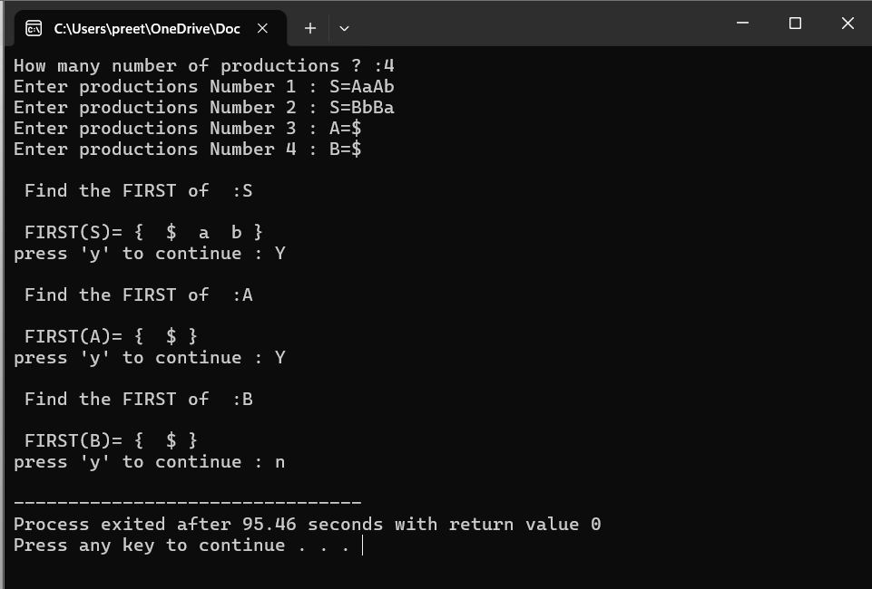

Exp:8
#include<stdio.h>
#include<ctype.h>
#include<string.h>
int limit, x = 0;
char production[10][10], array[10];

void find_first(char ch);
void find_follow(char ch);
void Array_Manipulation(char ch);

int main()
{
int count;
char option, ch;
printf("\nEnter Total Number of Productions:\t");
scanf("%d", &limit);
for(count = 0; count < limit; count++)
{
printf("\nValue of Production Number [%d]:\t", count + 1);
scanf("%s", production[count]);
}
do
{
x = 0;
printf("\nEnter production Value to Find Follow:\t");
scanf(" %c", &ch);
find_follow(ch);
printf("\nFollow Value of %c:\t{ ", ch);
for(count = 0; count < x; count++)
{
printf("%c ", array[count]);
}
printf("}\n");
printf("To Continue, Press Y:\t");
scanf(" %c", &option);
}while(option == 'y' || option == 'Y');
return 0;
}

void find_follow(char ch)
{
int i, j;
int length = strlen(production[i]);
if(production[0][0] == ch)
{
Array_Manipulation('$');
}
for(i = 0; i < limit; i++)
{
for(j = 2; j < length; j++)
{
if(production[i][j] == ch)
{
if(production[i][j + 1] != '\0')
{
find_first(production[i][j + 1]);
}
if(production[i][j + 1] == '\0' && ch != production[i][0])
{
find_follow(production[i][0]);
}
}
}
}
}

void find_first(char ch)
{
int i, k;
if(!(isupper(ch)))
{
Array_Manipulation(ch);
}
for(k = 0; k < limit; k++)
{
if(production[k][0] == ch)
{
if(production[k][2] == '$')
{
find_follow(production[i][0]);
}
else if(islower(production[k][2]))
{
Array_Manipulation(production[k][2]);
}
else
{
find_first(production[k][2]);
}
}
}
}

void Array_Manipulation(char ch)
{
int count;
for(count = 0; count <= x; count++)
{
if(array[count] == ch)
{
return;
}
}
array[x++] = ch;
}

Output:

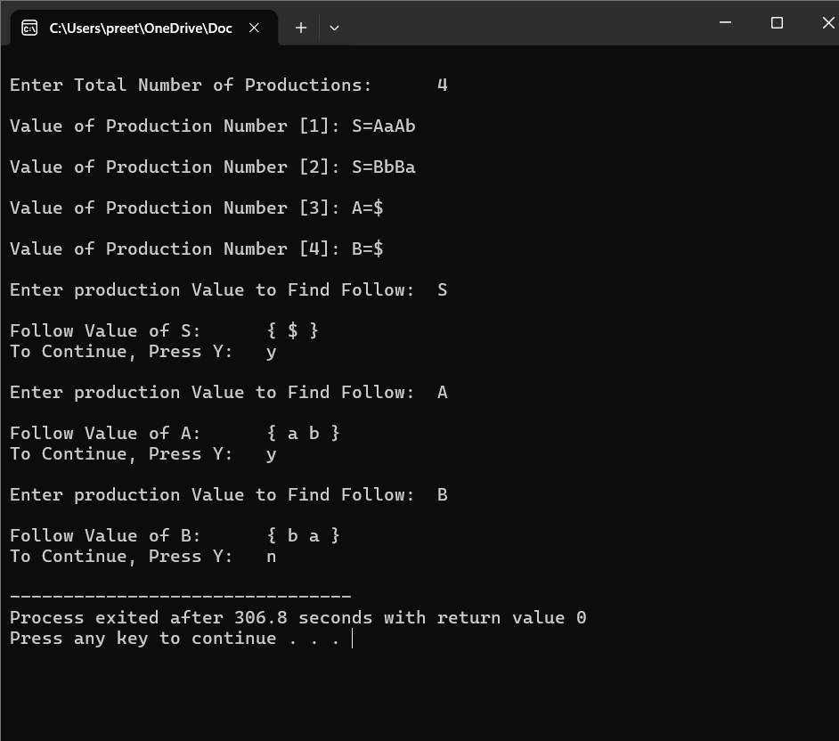
Exp:9
#include<stdio.h>
#include<string.h>
#define SIZE 10
int main () {
char non_terminal;
char beta,alpha;
int num;
char production[10][SIZE];
int index=3; /* starting of the string following "->" */
printf("Enter Number of Production : ");
scanf("%d",&num);
printf("Enter the grammar as E->E-A :\n");
for(int i=0;i<num;i++){
scanf("%s",production[i]);
}
for(int i=0;i<num;i++){
printf("\nGRAMMAR : : : %s",production[i]);
non_terminal=production[i][0];
if(non_terminal==production[i][index]) {
alpha=production[i][index+1];
printf(" is left recursive.\n");
while(production[i][index]!=0 && production[i][index]!='|')
index++;
if(production[i][index]!=0) {
beta=production[i][index+1];
printf("Grammar without left recursion:\n");
printf("%c->%c%c\'",non_terminal,beta,non_terminal);
printf("\n%c\'->%c%c\'|E\n",non_terminal,alpha,non_terminal);
}
else
printf(" can't be reduced\n");
}
else
printf(" is not left recursive.\n");
index=3;
}
}

Output:
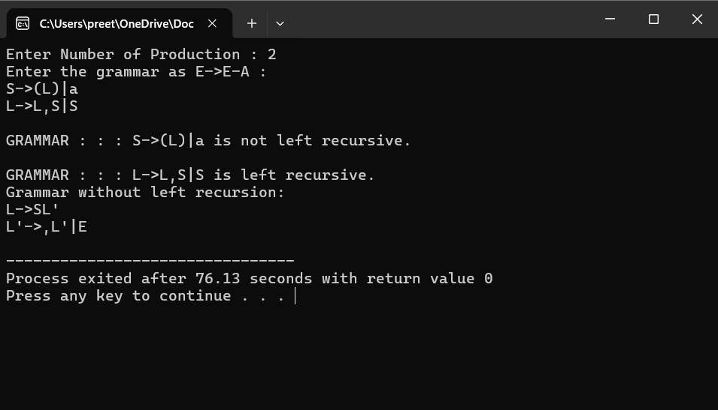

Exp:10
#include<stdio.h>
#include<string.h>

int main()
{
char gram[20], part1[20], part2[20], modifiedGram[20], newGram[20];
int i, j = 0, k = 0, l = 0, pos;

// Input production
printf("Enter Production: S->");
gets(gram);

// Extract part1 and part2
for(i = 0; gram[i] != '|'; i++, j++)
part1[j] = gram[i];
part1[j] = '\0';

for(j = ++i, i = 0; gram[j] != '\0'; j++, i++)
part2[i] = gram[j];
part2[i] = '\0';

// Find common prefix
for(i = 0; part1[i] == part2[i]; i++)
{
modifiedGram[k] = part1[i];
k++;
pos = i + 1;
}

// Create modified production
modifiedGram[k] = 'X';
modifiedGram[++k] = '\0';

// Create new production
for(i = pos, j = 0; part1[i] != '\0'; i++, j++)
newGram[j] = part1[i];
newGram[j++] = '|';
for(i = pos; part2[i] != '\0'; i++, j++)
newGram[j] = part2[i];
newGram[j] = '\0';

// Print the result
printf("\n S->%s", modifiedGram);
printf("\n X->%s\n", newGram);

return 0;
}

Output:
